**INSTALLATION OF JAVA JDK**

**STEP 1)** I have taken a flash that contains those program (JDK) and copy to my pc.

**STEP 2)** Once I finish copying in my pc, I have run the exe for install JDK after that I have been **click Next**

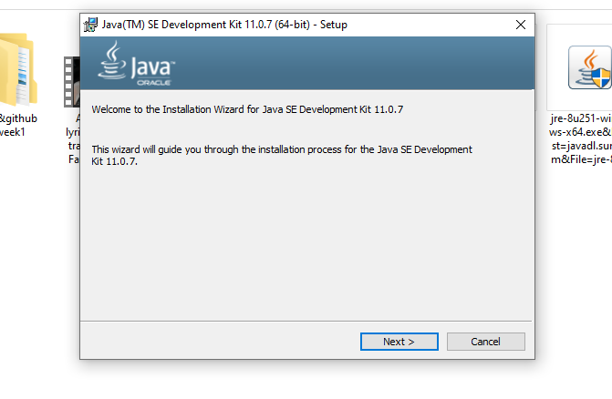

**STEP 3)** Then I selects the **PATH** to install Java in window. I have left it as Default then I **Click Next.**

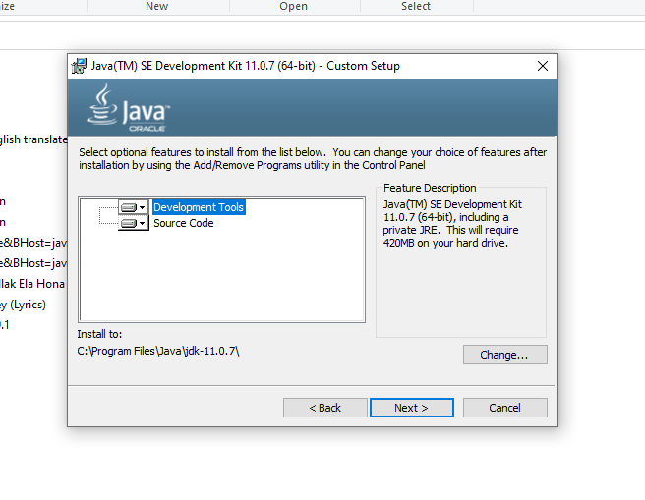

**STEP 4)** Once I have finish install Java in window, I **Click Close**

**STEP 5)** After I finish install Java in window, I started creating **Path** and **Classpath** in Java. I click this pc icon then the right click on my Computer and I select **Properties .**

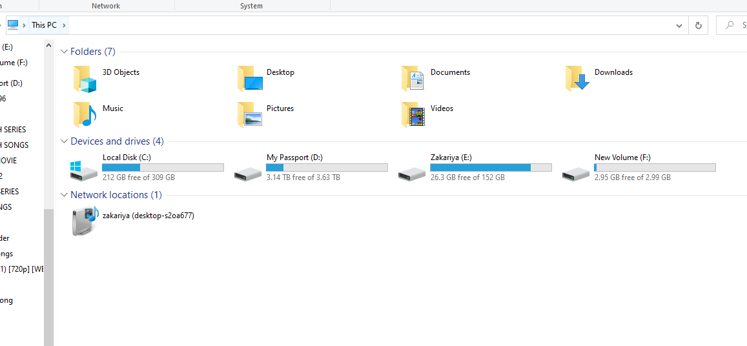

**STEP 6)** After that I click on **advanced system** setting.

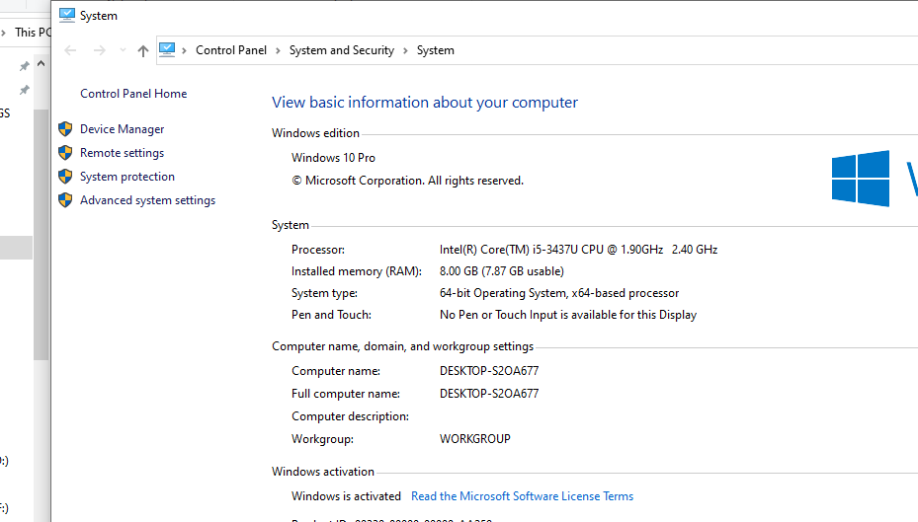

**STEPS 7)** Then I have Click on **Environment Variable** in order to set the Java runtime environment.

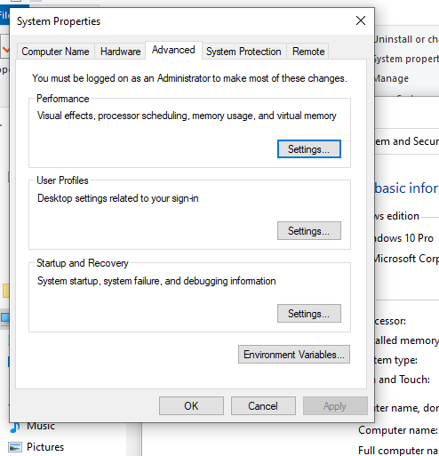

**STEP 8)** After entering in the Environment Variable I have been chopped in **Path.**

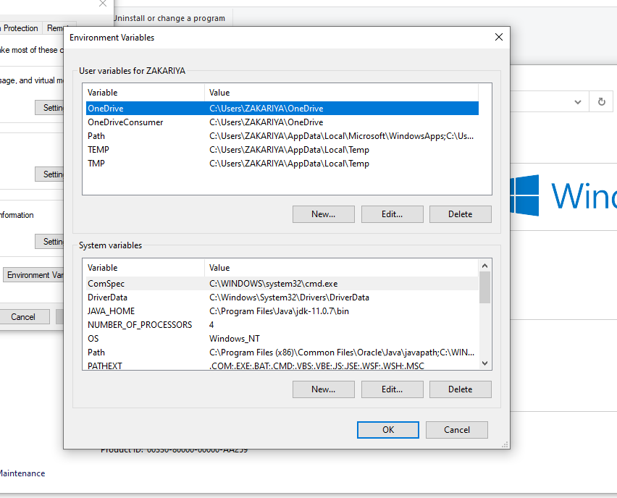

**STEP 9)** Then I Copy the path of bin which is installed in the JDK folder.

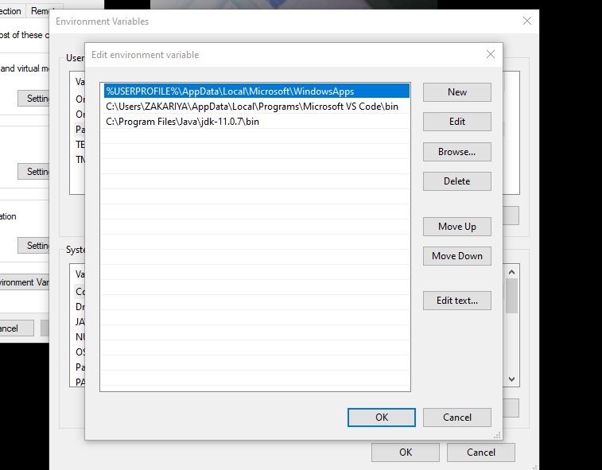

**STEP 10)**  After that I have go to the **System Variable** and I chose the **Path** the I click to the new button of System Variable and I type JAVA_HOME and also I paste the path of bin folder in **Variable Value.**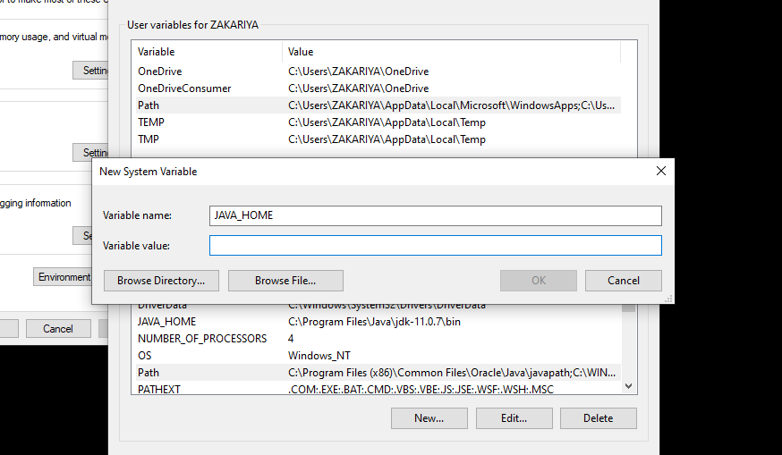

**ATEP 11)** Finally I go to the command prompt and type Javac command.

